Exercises: Implementing an OOP Hierarchy
Test your tasks in the Judge system: https://judge.softuni.org/Contests/4475/OOP-Hierarchy

Menu Item
We will be making a simple OOP project representing a restaurant. You'll be able to create different menu items, make new customers and manage their orders. Let's start by going into the MenuItem class:
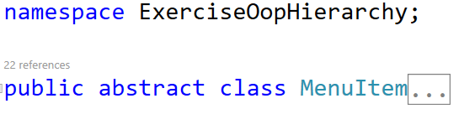
You can observe the class is abstract. We will use abstraction and inheritance to be able to make different items.
The class needs the following:
- Property Name – string.
- Property Description – string.
- Property Price – decimal.
- Method override ToString() - "{this.Name} - {this.Description} - ${this.Price}".
- Constructor accepting the three properties.

AppetizerMenuItem
Create a new class called AppetizerMenuItem and inherit from MenuItem. Call the base constructor and override the ToString() method: "Appetizer: {base.ToString()}"

MainCourseMenuItem
Create a new class called MainCourseMenuItem and inherit from MenuItem. Call the base constructor and override the ToString() method: "Main Course: {base.ToString()}"

DessertMenuItem
Create a new class called DessertMenuItem and inherit from MenuItem. Call the base constructor and override the ToString() method: "Dessert: {base.ToString()}"

Order
Create a new class called Order. This class will be responsible for keeping a list of menu items and being able to tell us the total all items cost.
Start by making a private list of menu items named _items. We will use encapsulation to protect the collection from outside use. To still be able to use it create an AddItem(MenuItem item) method to be able to add an item to the collection from the outside. Using polymorphism, we will be able to add any menu item:
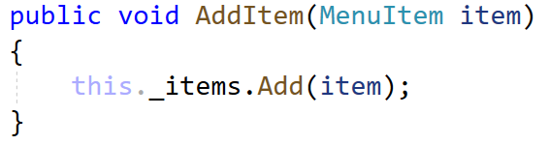
We also need the method for getting the total amount, so create a method decimal GetTotal() and return the total price of each item in the collection.
To wrap the class up let's allow read only access to the collection by adding a IReadOnlyCollection property:

Customer
Create a new class called Customer. The customer will hold information for each of his orders. The class needs:
- Field _orderHistory – list of orders.
- Property Name – string.
- Property Email – string.
- Property OrderHistory – read only order collection from _orderHistrory.
- Constructor accepting the two properties.
- Method AddOrder(Order order) – adds the given order to the _orderHistory list.

Restaurant
The final class Restaurant will hold the most logic, combining all classes. Here is what the class will have:
- Field _customers – list of customers.
- Field _menu – list of menu items.
- Method AddCustomer(Customer customer) – adds the given customer to the _customers list.
- Method GetMenuItem(int index) – returns the menu item at the given index.
  - Check if the index is in bounds! If not throw an IndexOutOfRangeException.
- Method AddMenuItem(MenuItem item) – adds the given menu item to the _menu list.
- Method PlaceOrder(Customer customer, Order order) – adds the given order to the customers _orderHistory list through the method we wrote.
- Method DisplayMenu() – First write to the console "Menu Items:" then foreach menu item in _menu write the item to the console.
- Method DisplayOrderHistory(Customer customer) – First:
  - Write to the console "{customer.Name}'s Order History:".
  - Then foreach order in the customers read only order collection write to the console "Order Total: ${order.GetTotal()}".
  - Finally foreach item in the orders items write to the console on each line " {item}".
All these methods allow us to communicate with the collection not only in this class but in others.
Now go ahead and run the code in Program.cs and look at the result!
